Contents

Chapter(2): Nanomaterials for water desalination 2

2.1 History of nanomaterials: 2

2.2What are nanomaterials? 4

2.3 Physical and Chemical Properties of Nanomaterials : 6

2.4 Nanomaterials used in water desalination: 6

2.4.1 Zero-Valent Metal Nanoparticles: 9

2.4.2  Metal Oxides Nanoparticles: 15

2.4.3 Carbon Nanotubes: 17

2.4.4  Nanocomposites: 19

# Chapter(2): Nanomaterials for water desalination

## 2.1 History of nanomaterials:

Nanoparticles and structures have been used by humans in fourth century AD, by the Roman, which demonstrated one of the most interesting examples of nanotechnology in the ancient world. The Lycurgus cup, from the British Museum collection, represents one of the most outstanding achievements in ancient glass industry. It is the oldest famous example of dichroic glass. Dichroic glass describes two different types of glass, which change color in certain lighting conditions. This means that the Cup have two different colors: the glass appears green in direct light, and red-purple when light shines through the glass

Figure1 The Lycurgus cup

In 1990, the scientists analyzed the cup using a transmission electron microscopy (TEM) to explain the phenomenon of dichroism. The observed dichroism (two colors) is due to the presence of nanoparticles with 50–100 nm in diameter. X-ray analysis showed that these nanoparticles are silver-gold (Ag-Au) alloy, with a ratio of Ag:Au of about 7:3, containing in addition about 10% copper (Cu) dispersed in a glass matrix. The Au nanoparticles produce a red color as result of light absorption (~520 nm). The red-purple color is due to the absorption by the bigger particles while the green color is attributed to the light scattering by colloidal dispersions of Ag nanoparticles with a size > 40 nm. The Lycurgus cup is recognized as one of the oldest synthetic nanomaterials. A similar effect is seen in late medieval church windows, shining a luminous red and yellow colors due to the fusion of Au and Ag nanoparticles into the glass.

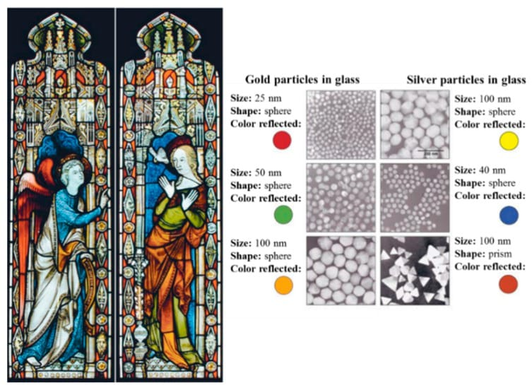Figure 2: shows an example of the effect of these nanoparticles withdifferent sizes tothe stained glass windows

During the 9th–17th centuries, glowing, glittering “luster” ceramic glazes used in the Islamic world, and later in Europe contained Ag or copper (Cu) or other nanoparticles. The Italians also employed nanoparticles in creating Renaissance pottery during 16th century . They were influenced by Ottoman techniques: during the 13th–18th centuries, to produce “Damascus” saber blades, cementite nanowires and carbon nanotubes were used to provide strength, resilience, and the ability to hold a keen edge. These colors and material properties were produced intentionally for hundreds of years. Medieval artists and forgers, however, did not know the cause of these surprising effects.

In 1857, Michael Faraday studied the preparation and properties of colloidal suspensions of “Ruby” gold. Their unique optical and electronic properties make them some of the most interesting nanoparticles. Faraday demonstrated how gold nanoparticles produce different-colored solutions under certain lighting conditions.

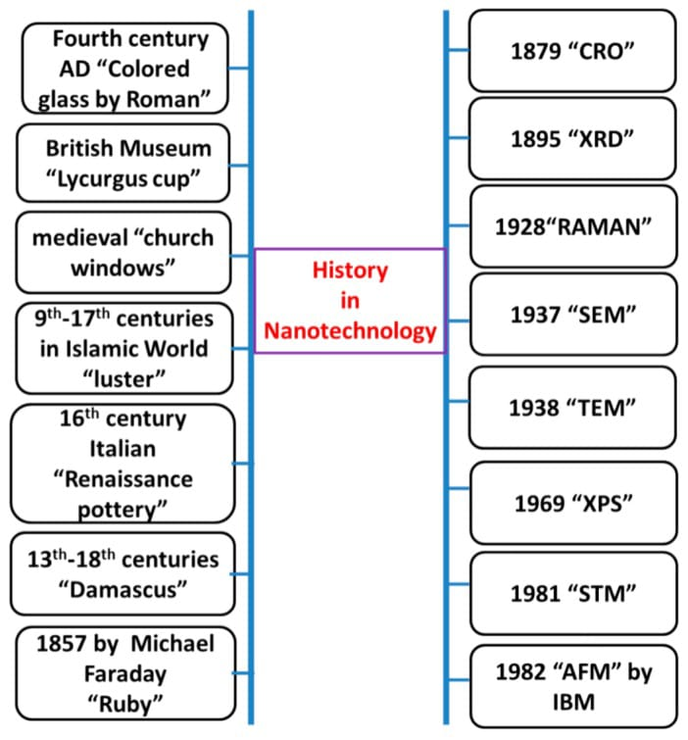Figure 3 progresses in Nanotechnology

## 2.2What are nanomaterials?

Nanotechnology is the general term for designing and making anything whose use depends on specific structure at the nanoscale – generally taken as being 100 nanometres (100 millionths of a millimetre or 100 billionths of a metre) or less. It includes devices or systems made by manipulating individual atoms or molecules, as well as materials which contain very small structures.

Nanomaterials are usually considered to be materials with at least one external dimension that measures 100 nanometres or less or with internal structures measuring 100 nm or less. They may be in the form of particles, tubes, rods or fibres.

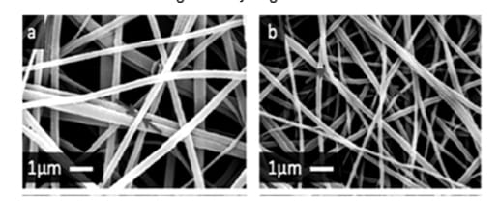Nanofibre: nano-object with two similar external dimensions in the nanoscale and the third significantly larger.

NanoPlates: nano-object with two similar external dimensions in the nanoscale and the third significantly smaller and in nanoscale.

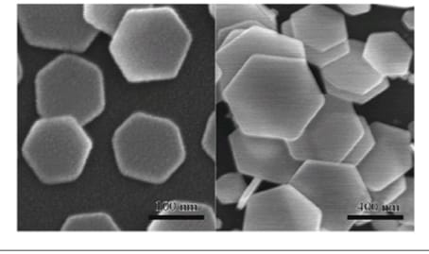

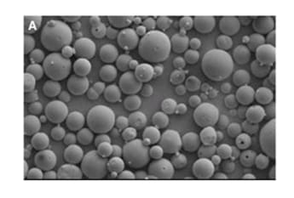Nanoparticle: nano-object with all three external dimensions in the nanoscale.

The nanomaterials that have the same composition as known materials in bulk form may have different physico-chemical properties than the same materials in bulk form, and may behave differently if they enter the body. They may thus pose different potential hazards.

The number of products produced by nanotechnology or containing nanomaterials entering the market is increasing. Current applications include healthcare (in targeted drug delivery, regenerative medicine, and diagnostics), electronics, cosmetics, textiles, information technology and environmental protection. For example, nanosilver is appearing in a range of products, including washing machines, socks, food packaging, wound dressings and food supplements. Food supplements need especially close scrutiny.

## 2.3 Physical and Chemical Properties of Nanomaterials :

Key factors for the unique properties of nanomaterials:

1.Large no. of boundaries

2.Large no. of active sites

3.High Surface/volume ratio.

4.Reduced probability of defects

5.High surface energy

## 2.4 Nanomaterials used in water desalination:

As we mentioned in the first chapter, there are many ways to desalinate water, and we knew that filtration is an existing technology for water purification that is more energy-efficient and safer compared to other ways .

**Membrane size system:**

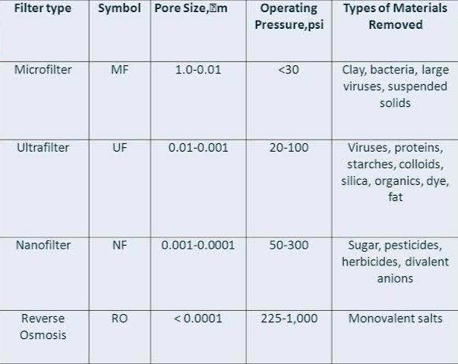

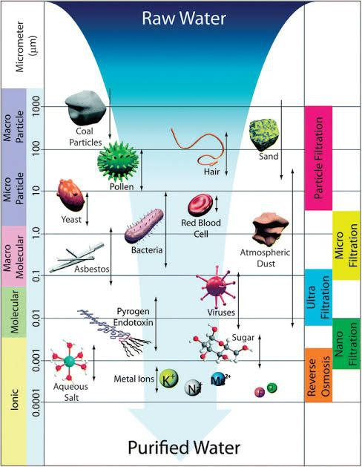

Schematic representation of various membrane processes, including reverse osmosis, NF, ultrafiltration, microfiltration and traditional particle filtration, in which the membrane pore size grows proportionally

**The aimed filter:**

A filtration system that can effectively remove organic , inorganic and pathogenic pollutants at their nanoscale a single process with antifouling performance.

The performance of a membrane is mainly governed by the structure of its pores and the mechanical / physical / chemical / the mal stability of the material .

**Developed Membrane Materials:**

Nanomaterials were used in the manufacture of membranes which made them with larger surface to mass ratio , lower density and pore sizes , high flux , higher porosity and exhibit higher separation efficiency such that:

### 2.4.1 Zero-Valent Metal Nanoparticles:

**2.4.1.1 Silver Nanoparticles:**

Silver nanoparticles (Ag NPs) are highly toxic to microorganisms and thus have strong antibacterial effects against a wide range of microorganisms, including viruses, bacteria, and fungi. As a good antimicrobial agent, silver nanoparticles have been widely used for the disinfection of water.

The mechanism of the antimicrobial effects of Ag NPs is not clearly known and remains under debate. In recent years, several theories have been put forward. Ag NPs have been reported to be able to adhere to the bacterial cell wall and subsequently penetrate it, resulting in structural changes of the cell membrane and thus increasing its permeability. Besides, when Ag NPs are in contact with bacteria, free radicals can be generated. They have the ability to damage the cell membrane and are considered to cause the death of cells. In addition, as DNA contains abundant sulfur and phosphorus elements, Ag NPs can act with it and thus destroy it. This is another explanation for the death of cells caused by Ag NPs. What is more, the dissolution of Ag NPs will release antimicrobial Ag+ ions, which can interact with the thiol groups of many vital enzymes, inactivate them, and disrupt normal functions in the cell.

With the development of nanotechnology, Ag NPs have been successfully applied in water and wastewater disinfection in recent years. Direct application of Ag NPs might cause some problems, such as their tendency to aggregate in aqueous media that gradually reduces their efficiency during long-term use. Ag NPs attached to filter materials have been considered promising for water disinfection due to their high antibacterial activity and cost-effectiveness.

Via the in situ reduction of silver nitrate, Ag NPs have been deposited on the cellulose fibers of an absorbent blotting paper sheet (see Figure [1](https://www.hindawi.com/journals/amse/2016/4964828/fig1/)). The Ag NPs sheets showed antibacterial properties towards suspensions of*Escherichia coli* and*Enterococcus faecalis* and inactivated bacteria during filtration through the sheet. Moreover, the silver loss from the Ag NPs sheets was lower than the standards for silver in drinking water put forward by Environmental Protection Agency (EPA) and World Health Organization (WHO. Therefore, for water contaminated by bacteria, filtration through paper deposited with Ag NPs could be an effective emergency water treatment. Besides, Ag NPs synthesized by chemical reduction have been incorporated into polyethersulfone (PES) microfiltration membranes. The activity of microorganisms nearby the membranes was observed to be remarkably suppressed. The PES-Ag NPs membranes exhibited strong antimicrobial properties and held great potential in application for water treatment .

Silver nanoparticles (Ag NPs) are highly toxic to microorganisms and thus have strong antibacterial effects against a wide range of microorganisms, including viruses, bacteria, and fungi. As a good antimicrobial agent, silver nanoparticles have been widely used for the disinfection of water.

The mechanism of the antimicrobial effects of Ag NPs is not clearly known and remains under debate. In recent years, several theories have been put forward. Ag NPs have been reported to be able to adhere to the bacterial cell wall and subsequently penetrate it, resulting in structural changes of the cell membrane and thus increasing its permeability. Besides, when Ag NPs are in contact with bacteria, free radicals can be generated. They have the ability to damage the cell membrane and are considered to cause the death of cells. In addition, as DNA contains abundant sulfur and phosphorus elements, Ag NPs can act with it and thus destroy it. This is another explanation for the death of cells caused by Ag NPs. What is more, the dissolution of Ag NPs will release antimicrobial Ag+ ions, which can interact with the thiol groups of many vital enzymes, inactivate them, and disrupt normal functions in the cell.

With the development of nanotechnology, Ag NPs have been successfully applied in water and wastewater disinfection in recent years. Direct application of Ag NPs might cause some problems, such as their tendency to aggregate in aqueous media that gradually reduces their efficiency during long-term use. Ag NPs attached to filter materials have been considered promising for water disinfection due to their high antibacterial activity and cost-effectiveness .

Via the in situ reduction of silver nitrate, Ag NPs have been deposited on the cellulose fibers of an absorbent blotting paper sheet (see Figure [1](https://www.hindawi.com/journals/amse/2016/4964828/fig1/)). The Ag NPs sheets showed antibacterial properties towards suspensions of*Escherichia coli* and*Enterococcus faecalis* and inactivated bacteria during filtration through the sheet. Moreover, the silver loss from the Ag NPs sheets was lower than the standards for silver in drinking water put forward by Environmental Protection Agency (EPA) and World Health Organization (WHO). Therefore, for water contaminated by bacteria, filtration through paper deposited with Ag NPs could be an effective emergency water treatment. Besides, Ag NPs synthesized by chemical reduction have been incorporated into polyethersulfone (PES) microfiltration membranes. The activity of microorganisms nearby the membranes was observed to be remarkably suppressed. The PES-Ag NPs membranes exhibited strong antimicrobial properties and held great potential in application for water treatment

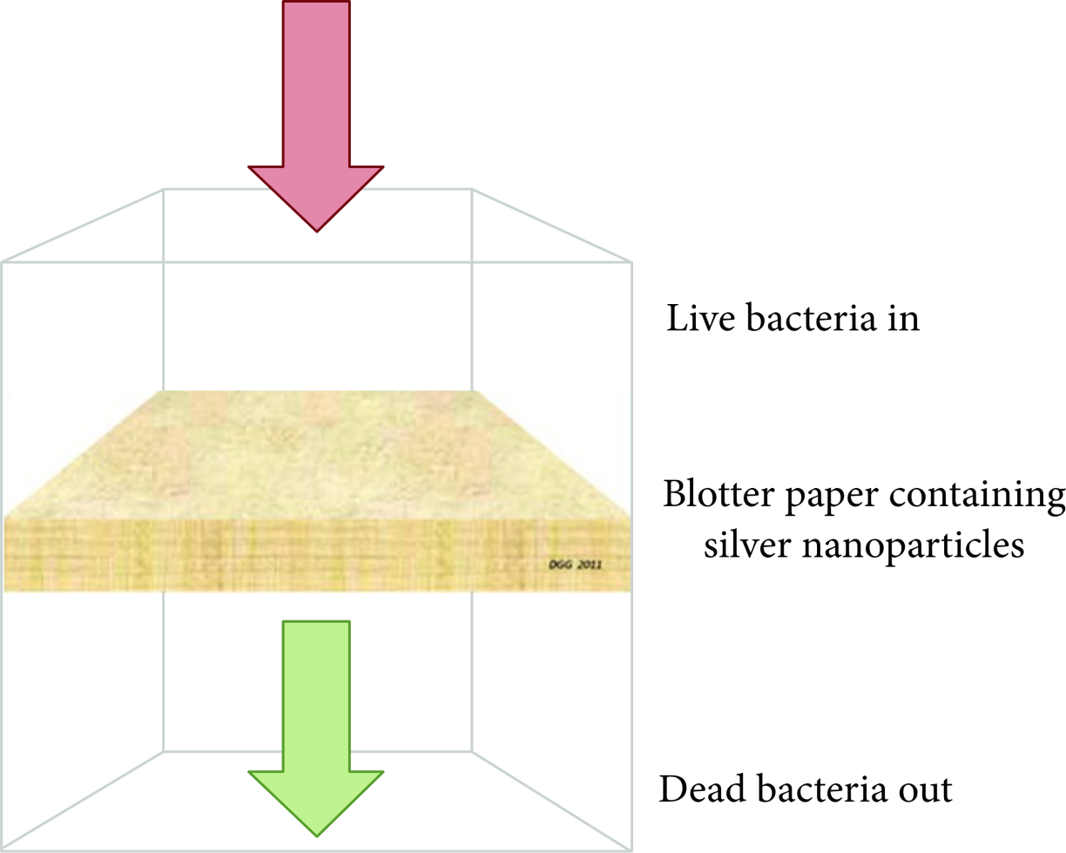

**Figure 1** :

Schematic presentation of the disinfection process of blotter paper containing silver nanoparticles.

**2.4.1.2 Iron Nanoparticles:**

In recent years, various zero-valent metal nanoparticles, such as Fe, Zn, Al, and Ni, in water pollution treatment have drawn wide research interest. The standard reduction potentials of Fe, Al, Ni, and Zn are listed in Table [1](https://www.hindawi.com/journals/amse/2016/4964828/tab1/). Due to the extremely high reductive ability, nano-zero-valent Al is thermodynamically unstable in the presence of water, which favors the formation of oxides/hydroxides on the surface, impeding (completely) the transfer of electrons from the metal surface to the contaminant. Compared with Fe, Ni has a less negative standard reduction potential, indicating a lower reducing ability. With a moderate standard reduction potential, nano-zero-valent Fe or Zn holds good potential to act as reducing agents relative to many redox-labile contaminants. Despite a weaker reduction ability, Fe possesses many prominent advantages over Zn for applications in water pollution treatment, including excellent adsorption properties, precipitation and oxidation (in the presence of dissolved oxygen), and low cost. Therefore, zero-valent iron nanoparticles have been the most extensively studied zero-valent metal nanoparticles.

**Table 1**: The standard reduction potentials of different metals

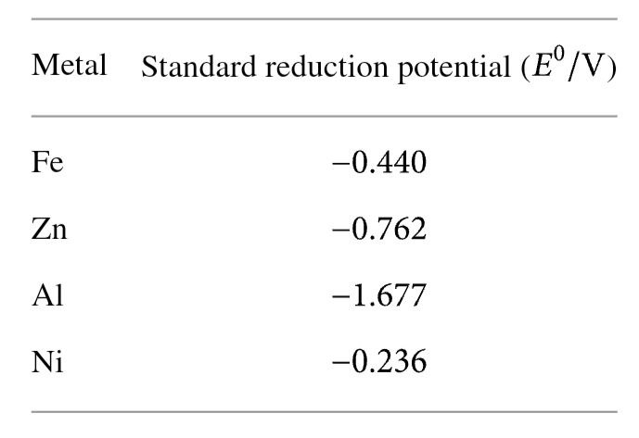

**2.4.1.3  Zinc Nanoparticles:**

Although most studies on contaminant degradation in water and wastewater treatment by zero-valent metal nanoparticles have been focused on iron, Zn has also been considered as an alternative [48]. With a more negative standard reduction potential (Table [1](https://www.hindawi.com/journals/amse/2016/4964828/tab1/)), Zn is a stronger reductant compared with Fe. Therefore, the contaminant degradation rate of zinc nanoparticles may be faster than that of nZVI.

For the application of nano-zero-valent zinc (nZVZ), most studies have been focused on dehalogenation reaction. Research indicated that the reduction rates of CCl4 by nZVZ were more significantly affected by solution chemistry than particle size or surface morphology. By comparing the reactivity of various types of nZVI and nZVZ, it was found that nZVZ could degrade CCl4 more rapidly and completely than nZVI under favorable conditions [49]. Besides, a study has been carried out to examine the degradation of octachlorodibenzo-p-dioxin (OCDD) in water with four different zero-valent metal nanoparticles: zero-valent zinc (nZVZ), zero-valent iron (nZVI), zero-valent aluminum (nZVAL), and zero-valent nickel (nZVN). On the basis of experimental results, only nZVZ was able to efficiently degrade OCDD into lower chlorinated congeners and thus became the first reported zero-valent metal nanoparticles suitable for OCDD dechlorination under ambient conditions [48].

However, although several studies have demonstrated that contaminant reduction by nZVZ could be successful, the application of nZVZ is mainly limited in the degradation of halogenated organic compounds, especially CCl4. The treatment of other kinds of contaminants by nZVZ has rarely been reported up to now. Therefore, pilot-scale or full-scale applications of nZVZ have not been achieved at contaminated field sites yet

### 2.4.2  Metal Oxides Nanoparticles:

**2.4.2.1  TiO2 Nanoparticles:**

The majority of common photocatalysts are metal oxide or sulfide semiconductors, among which TiO2 has been most extensively investigated in the past decades. Owing to its high photocatalytic activity, reasonable price, photostability, and chemical and biological stability, TiO2 is the most exceptional photocatalyst to date. The large band gap energy (3.2 eV) of TiO2 requires ultraviolet (UV) excitation to induce charge separation within the particles. As shown in Figure [2](https://www.hindawi.com/journals/amse/2016/4964828/fig2/), upon UV irradiation, TiO2 will generate reactive oxygen species (ROS) which can completely degrade contaminants in very short reaction time. Besides, TiO2 NPs show little selectivity and thus are suitable for the degradation of all kinds of contaminants, such as chlorinated organic compounds, polycyclic aromatic hydrocarbons , dyes, phenols, pesticides, arsenic, cyanide, and heavy metals. What is more, hydroxyl radicals generated under UV irradiation ( nm) enable TiO2 NPs to damage the function and structure of various cells. The photocatalytic properties of TiO2 NPs are able to kill a wide array of microorganisms, such as Gram-negative and Gram-positive bacteria, as well as fungi, algae, protozoa, and viruses.

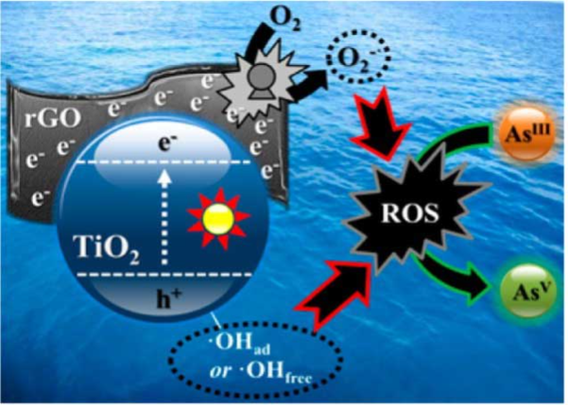

**Figure 2:** Schematic presentation of the mechanism of TiO2 photocatalytic process.

**2.4.2.2  ZnO Nanoparticles:**

In the field of photocatalysis, apart from TiO2 NPs, ZnO NPs have emerged as another efficient candidate in water and wastewater treatment because of their unique characteristics, such as direct and wide band gap in the near-UV spectral region, strong oxidation ability, and good photocatalytic property .

ZnO NPs are environment-friendly as they are compatible with organisms, which makes them suitable for the treatment of water and wastewater. Besides, the photocatalytic capability of ZnO NPs is similar to that of TiO2 NPs because their band gap energies are almost the same [84]. However, ZnO NPs have the advantage of low cost over TiO2 NPs. Moreover, ZnO NPs can adsorb a wider range of solar spectra and more light quanta than several semiconducting metal oxides.

Nevertheless, similar to that of TiO2 NPs, the light absorption of ZnO NPs is also limited in the ultraviolet light region due to their big band gap energies. Besides, the application of ZnO NPs is impeded by photocorrosion, which will result in fast recombination of photogenerated charges and thus cause low photocatalytic efficiency [86].

To improve the photodegradation efficiency of ZnO NPs, metal doping is a common strategy. Various types of metal dopants have been tested, including anionic dopants, cationic dopants, rare-earth dopants, and codopants. Besides, many studies have shown that coupling with other semiconductors, such as CdO, CeO2, SnO2, TiO2, graphene oxide (GO), and reduced graphene oxide (RGO), is a feasible approach to enhance the photodegradation efficiency of ZnO NPs.

**2.4.2.3 Iron Oxides Nanoparticles:**

In recent years, there is a growing interest in the use of iron oxides nanoparticles for the removal of heavy metal due to their simplicity and availability. Magnetic magnetite (Fe3O4) and magnetic maghemite (*γ*-Fe2O4) and nonmagnetic hematite (*α*-Fe2O3) are often used as nanoadsorbents.

Generally, due to the small size of nanosorbent materials, their separation and recovery from contaminated water are great challenges for water treatment. However, magnetic magnetite (Fe3O4) and magnetic maghemite (*γ*-Fe2O4) can be easily separated and recovered from the system with the assistance of an external magnetic field. Therefore, they have been successfully used as sorbent materials in the removal of various heavy metals from water systems.

### 2.4.3 Carbon Nanotubes:

Carbon nanomaterials (CNMs) are a class of fascinating materials due to their unique structures and electronic properties which make them attractive for fundamental studies as well as diverse applications, especially in sorption processes. Their advantages for water and wastewater treatment are due to (1) great capacity to adsorb a wide range of contaminants, (2) fast kinetics, (3) large specific surface area, and (4) selectivity towards aromatics. There are several forms of CNMs, such as carbon nanotubes (CNTs), carbon beads, carbon fibers, and nanoporous carbon. Among them, CNTs have attracted the most attentions and progressed rapidly in recent years.

Carbon nanotubes are graphene sheets rolled up in cylinders with diameter as small as 1 nm. CNTs have attracted great interest as an emerging adsorbent due to their unique properties. With an extremely large specific surface area and abundant porous structures, CNTs possess exceptional adsorption capabilities and high adsorption efficiencies for numerous kinds of contaminants, such as dichlorobenzene, ethyl benzene, Zn2+, Pb2+, Cu2+, and Cd2+, and dyes. According to their (super)structures, CNTs can be classified into two types (Figure [3](https://www.hindawi.com/journals/amse/2016/4964828/fig3/)): multiwalled carbon nanotubes (MWCNTs), which comprised multiple layers of concentric cylinders with a spacing of about 0.34 nm between the adjacent layers, and () single-walled carbon nanotubes (SWCNTs), which consist of single layers of graphene sheets seamlessly rolled into cylindrical tubes. In recent years, both MWCNTs and SWCNTs have been applied for the removal of contaminants in water.

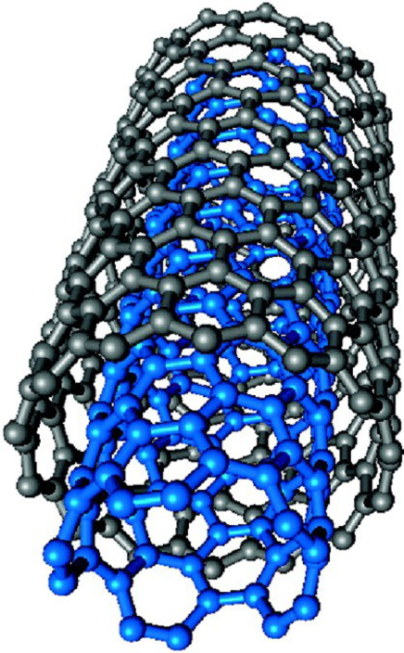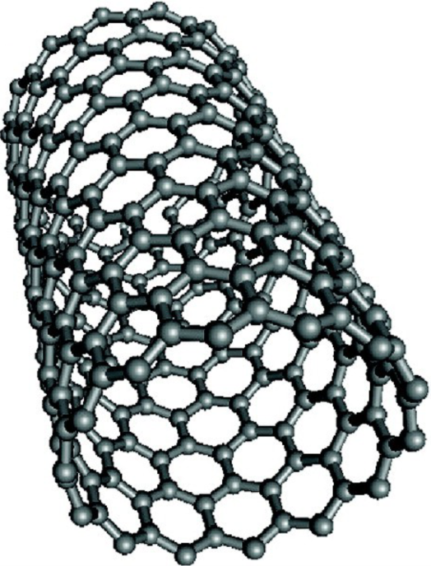  
 (a) (b)

**Figure 3**: (Super)structure representations of (a) MWCNTs and (b) SWCNTs.

To improve the adsorption, mechanical, optical, and electrical properties, carbon nanotubes are often combined with other metals or types of support. The functionalization increases the number of oxygen, nitrogen, or other groups on the surface of CNTs, enhances their dispersibility, and thus improves specific surface area. For example, a study using CNTs as a support for magnetic iron oxide has been reported by Gupta et al. Combining the adsorption properties of CNTs with the magnetic properties of iron oxide, a “composite” adsorbent was prepared to remove chromium from water. Apart from owning excellent adsorption properties, the “composite” adsorbent can be easily separated from water via an external magnetic field.

In spite of the exceptional properties of CNTs, the development and applications of CNTs are mainly limited by their low volume of production and high cost. Besides, CNTs cannot be used alone without any supporting medium or matrix to form structural components .

### 2.4.4  Nanocomposites:

As mentioned above, every nanomaterial has its own drawbacks. For example, nZVI has the disadvantages of aggregation, oxidation, and separation difficulty from the degraded systems. The light adsorption of TiO2 NPs and ZnO NPs is limited in the ultraviolet light region due to their big band gap energies. Nanofiltration membranes are troubled by the problem of membrane fouling. Carbon nanotubes are mainly limited by their low volume of production and high cost as well as the need for supporting medium or matrix. In order to overcome these problems and achieve better removal efficiency, it is a common and effective strategy to fabricate nanocomposites for water and wastewater treatment.

In recent years, the synthesis of various nanocomposites has become the most active subject in the field of nanomaterials. On the basis of numerous studies, much progress has been made throughout the world. For example, via chemical deposition of nZVI on CNTs, a novel nanoscale adsorbent was prepared. According to the results, the adsorbent has good potential for quick and effective removal of nitrate in water. Besides, due to its unique magnetic property, the adsorbent can be easily separated from the solution by the magnet. Besides, thin film nanocomposite (TFN) nanofiltration membranes have been prepared via in situ interfacial incorporation of TiO2 NPs along with fabrication of copolyamide network on a polyimide support. To improve the compatibility of TiO2 NPs inside the polymer matrix, both amine and chloride compounds were utilized to functionalize TiO2 NPs. TFN membranes exhibited higher methanol flux and dye rejection in spite of lower swelling degree. The loading of TiO2 NPs turned out to be a crucial factor on the NF membrane performance .

In theory, ideal composites for real applications should be continuous, bulk immobile materials of which the nanoreactivity is obtained by anchoring or impregnating a parent material structure with nanomaterials .What is more, it is widely acknowledged that the treatment of water and wastewater calls for nontoxic, long-term stable and low-cost materials. To obtain desirable nanocomposites, further research is still under way.